|  |  |
| --- | --- |
| Sl No | **Users** |
|  | Change Analyst |
|  | Approver |
|  | Support Engineer |

1. **Change Analyst: -** is capable of initiating and Closing a Change Request.
2. **Approver: -** is authorized solely to approve the various levels..
3. **Support Engineer: -** is responsible for implementing a specified number of tasks

**Login Page**

**Steps to be followed:**

**1.** Login with your Unnati Portal Credential.

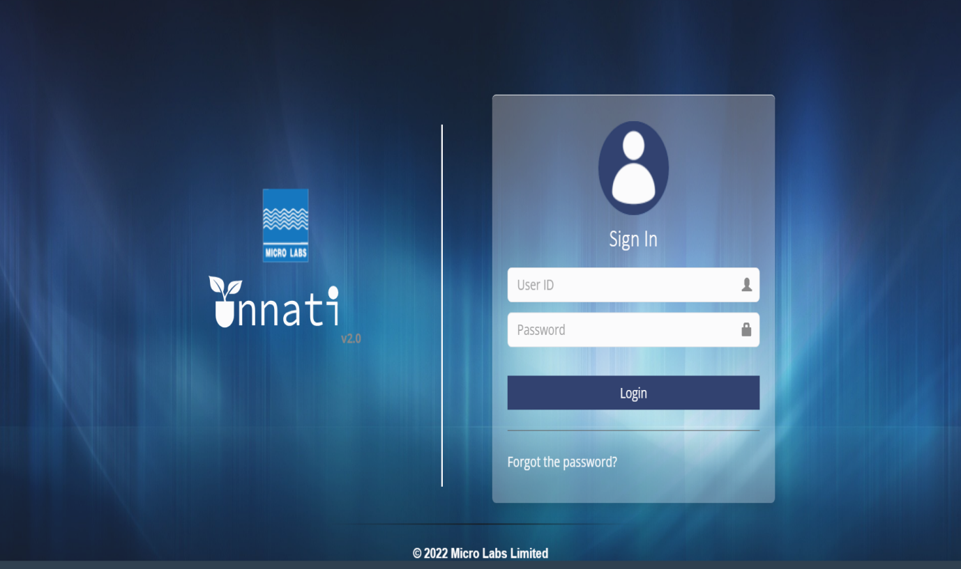

2.Login as an Analyst to Create a Change request(CR).

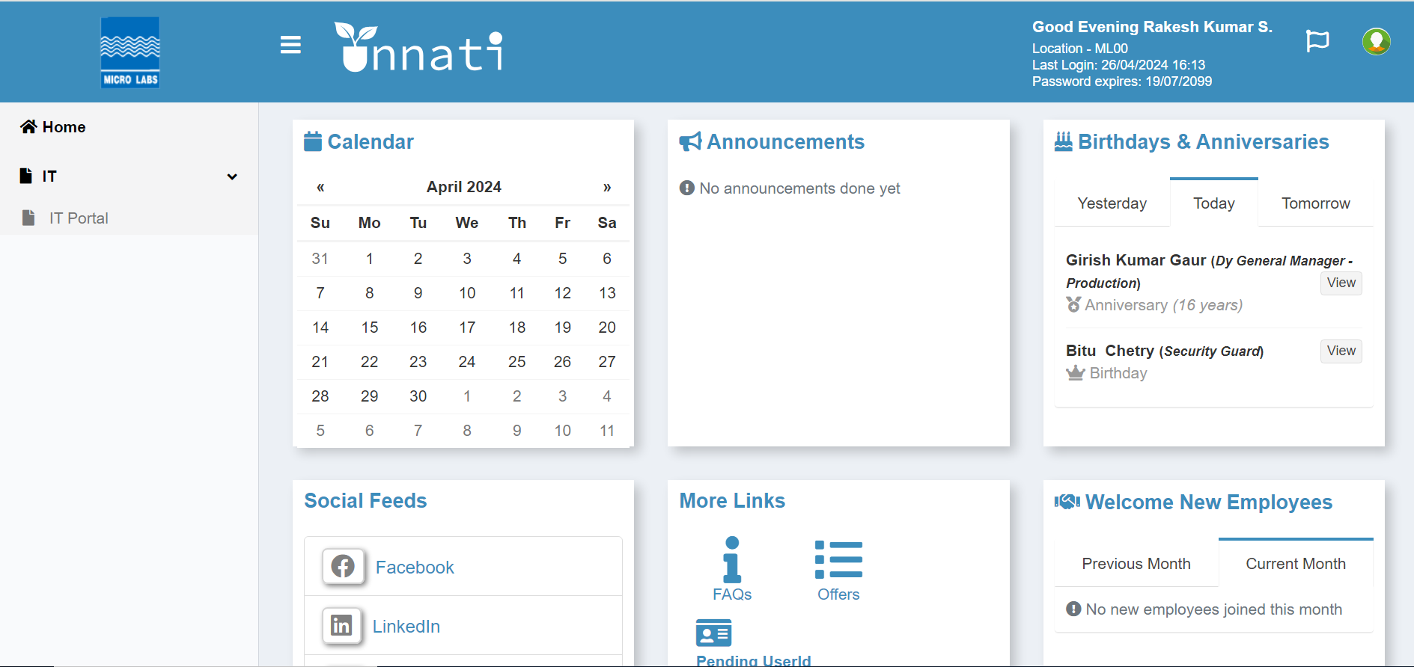

3.Click on IT on the Dropdown and click on IT Portal.

4.Click on IT Portal Button.

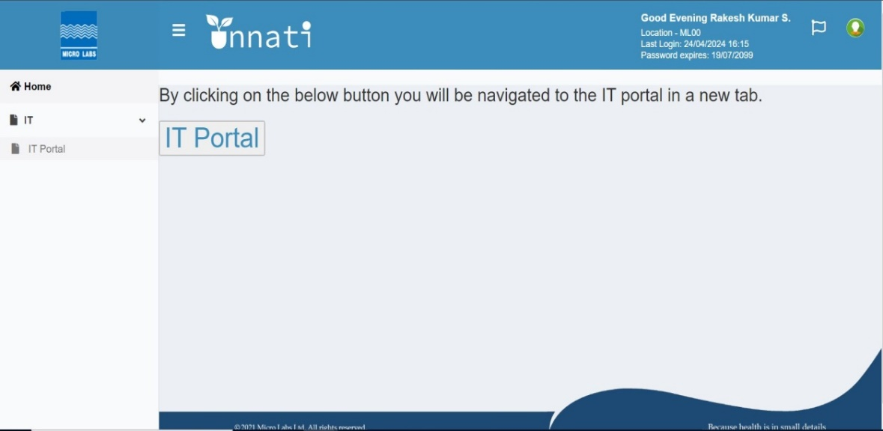

5.once clicked on IT portal button Dashboard will appear then click to create a new CR and the Dashboard will remain same to all the users.

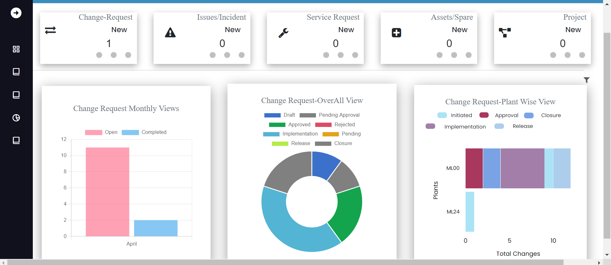

Then click to the button (Change New Request) to create new request.

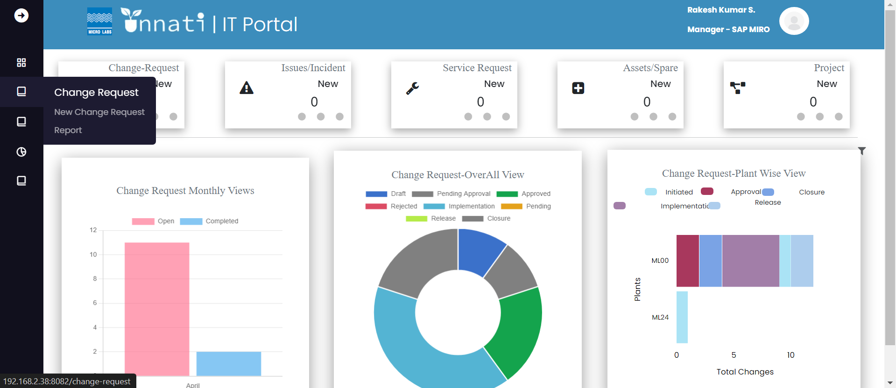

Once clicked on create new you will find form asking for required details.

(Change owner name – Initiator name – RFC Date – Plant – Reference – Reference type – Classifications – Category – Sub-category – Nature of change – Priority – Change requested by – Change requested on- Change triggered by)

Note: If Initiator name and the change owner is same then select checkbox.

Note: in the form of CR you will find multiple Dropdown select each as per the requirement.

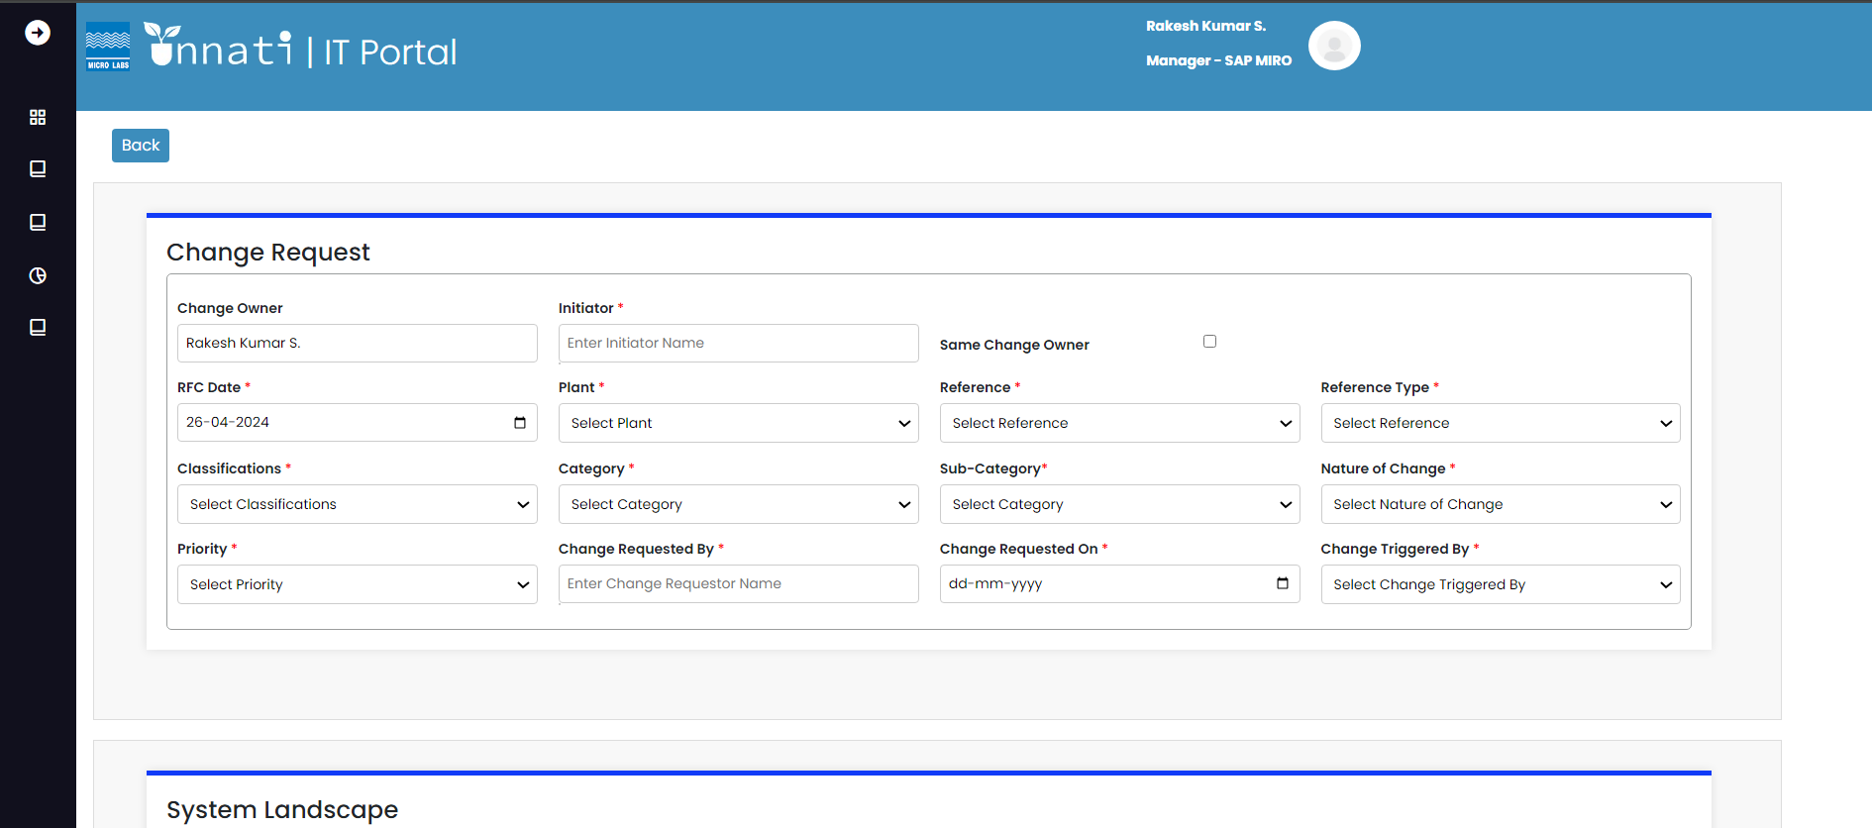

System landscape depends based on the Classifications and Category

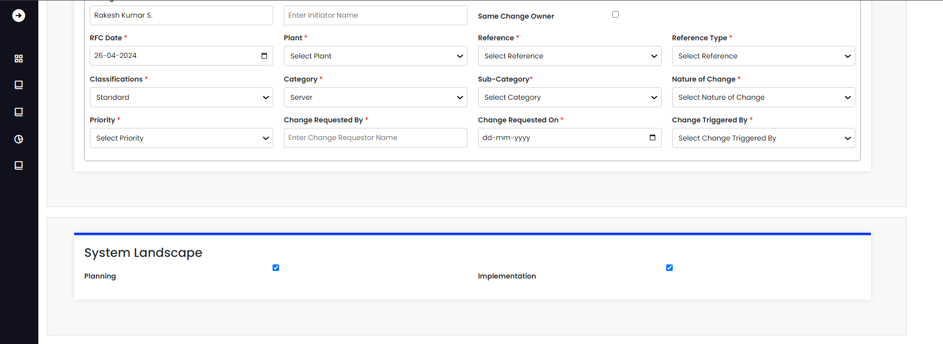

Fill all the required fields.

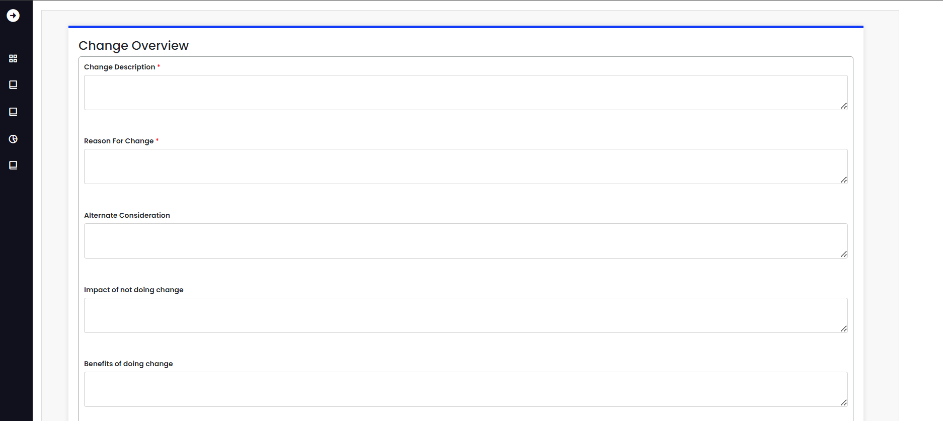

Select the time line for given task.

(Approx cost – Currency – Estimated effort – effort days/hours – expected date of completion)

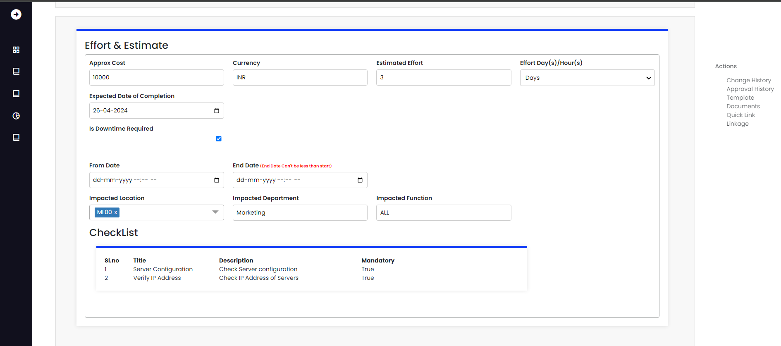

Fill the Gxp Classifications fields and click on Save.

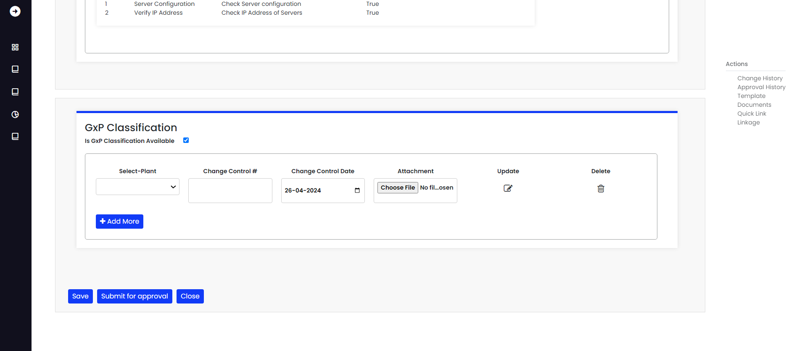

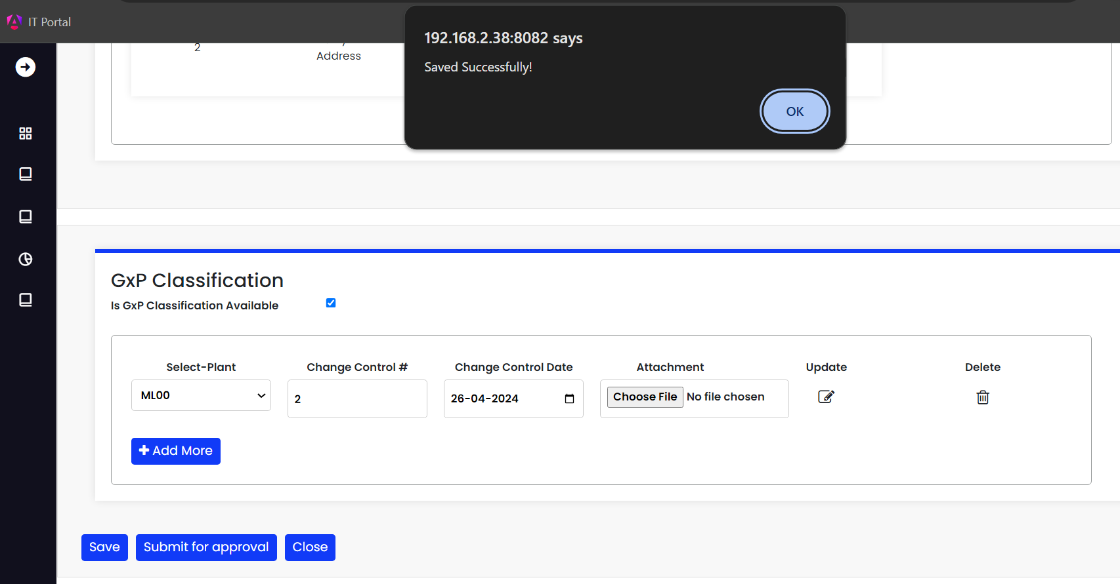

Once it is saved successfully you will find out as a Draft in created.

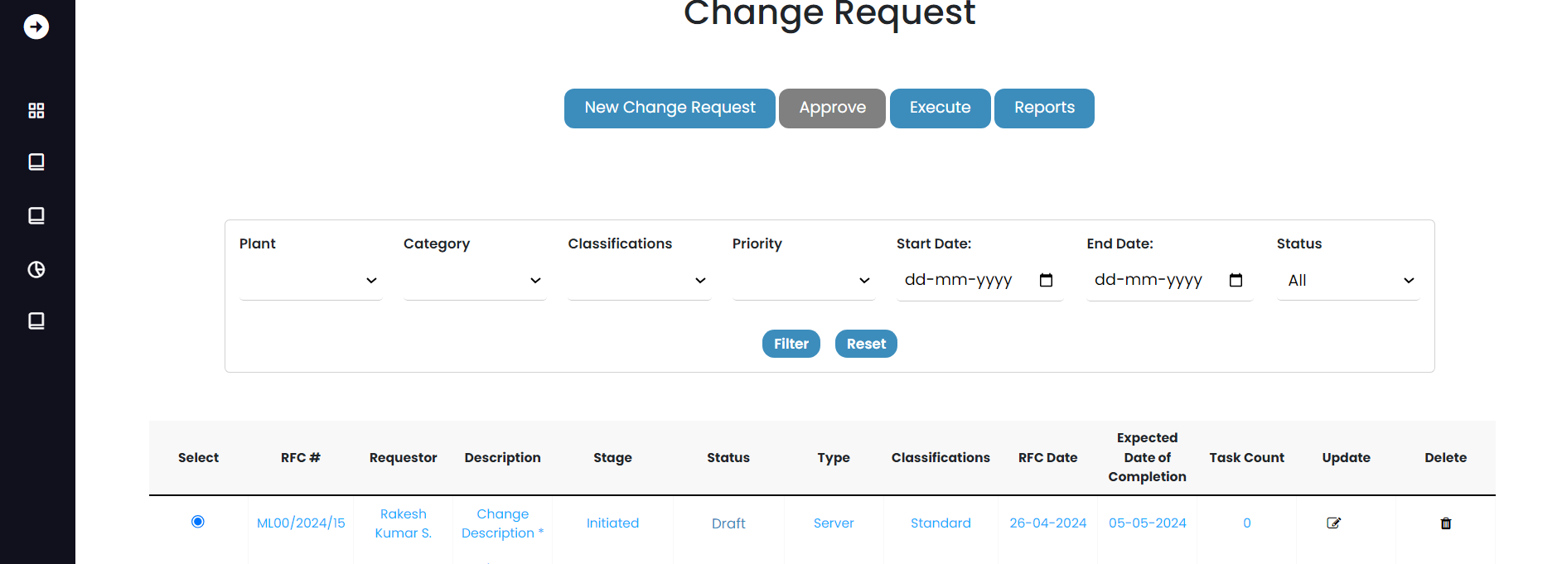

If modification is required,Click on the radio button of particular CR and press on Update button and start modification once it is done click on submit button.



Once CR is updated click on Submit for approval button.

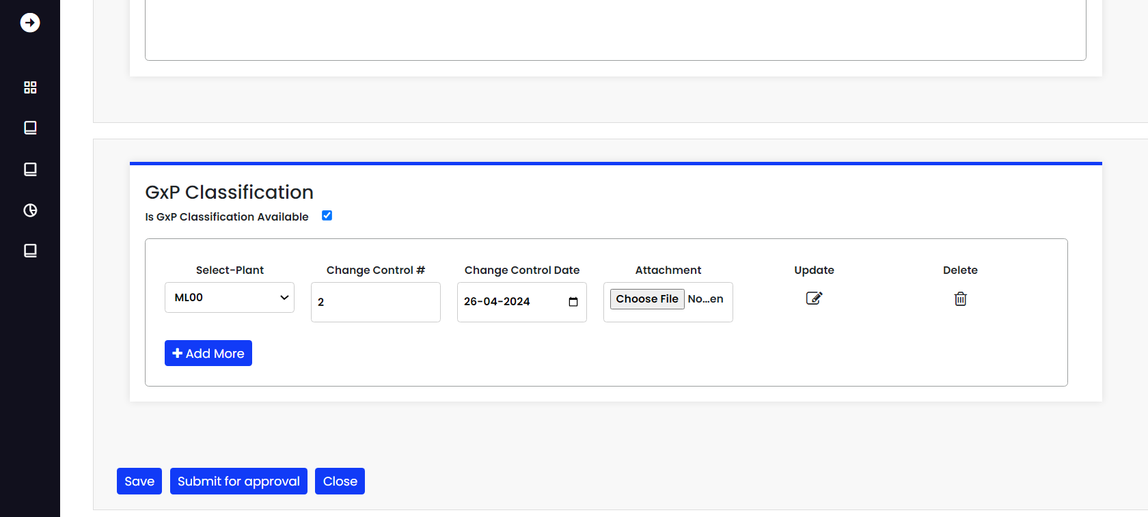

Once it is clicked on submit it will give you a pop up message submitted successfully.

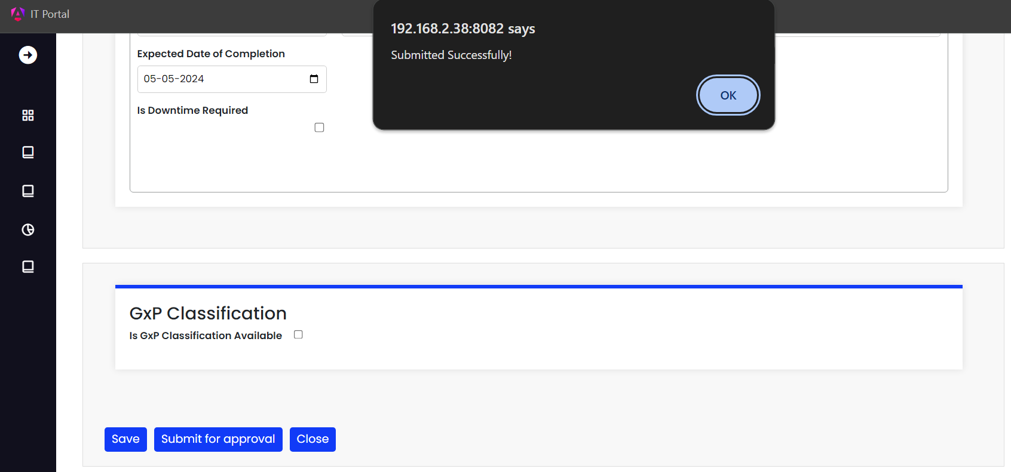

Once the submission is done the CR will be update as pending for approval as given below.

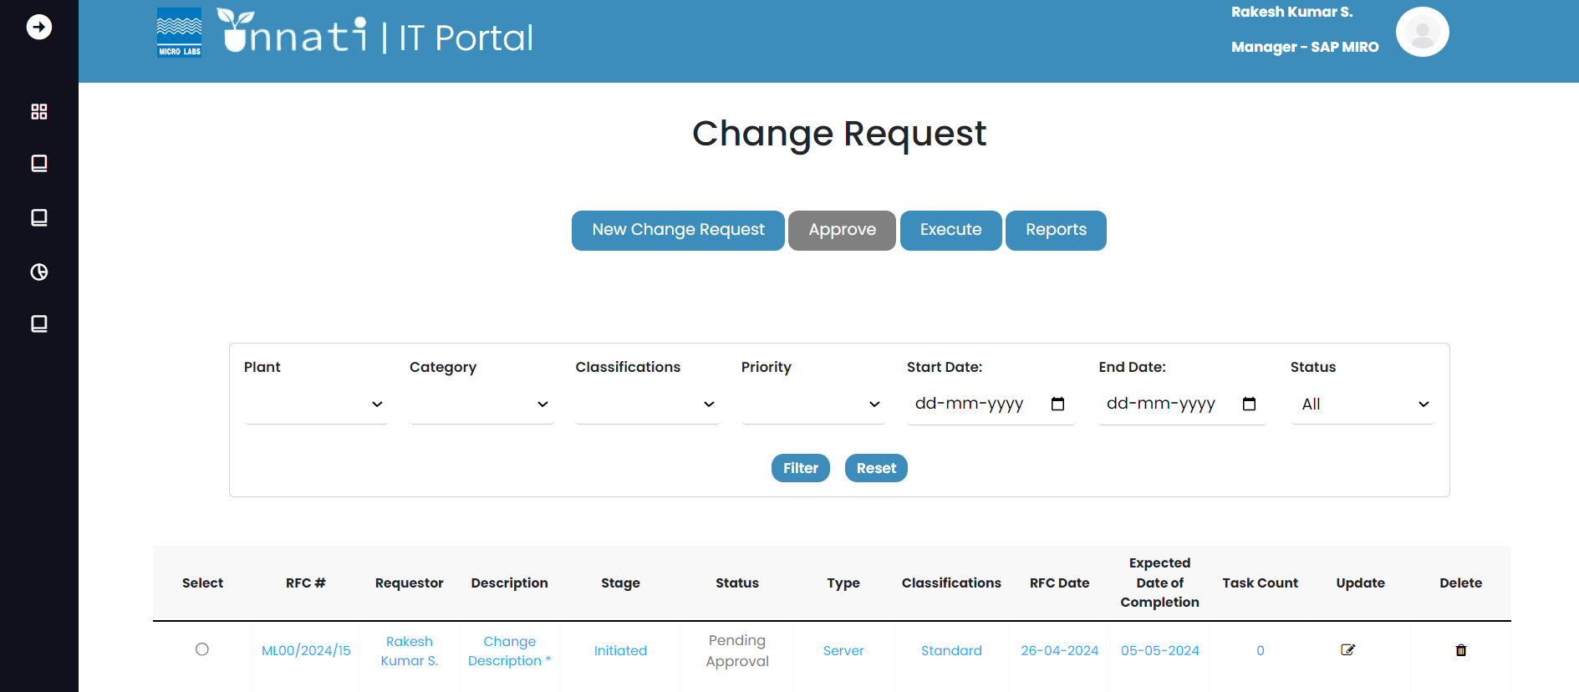

As a Change analyst you will be able see only three buttons i.e.

* New change request
* Execute button
* Reports button

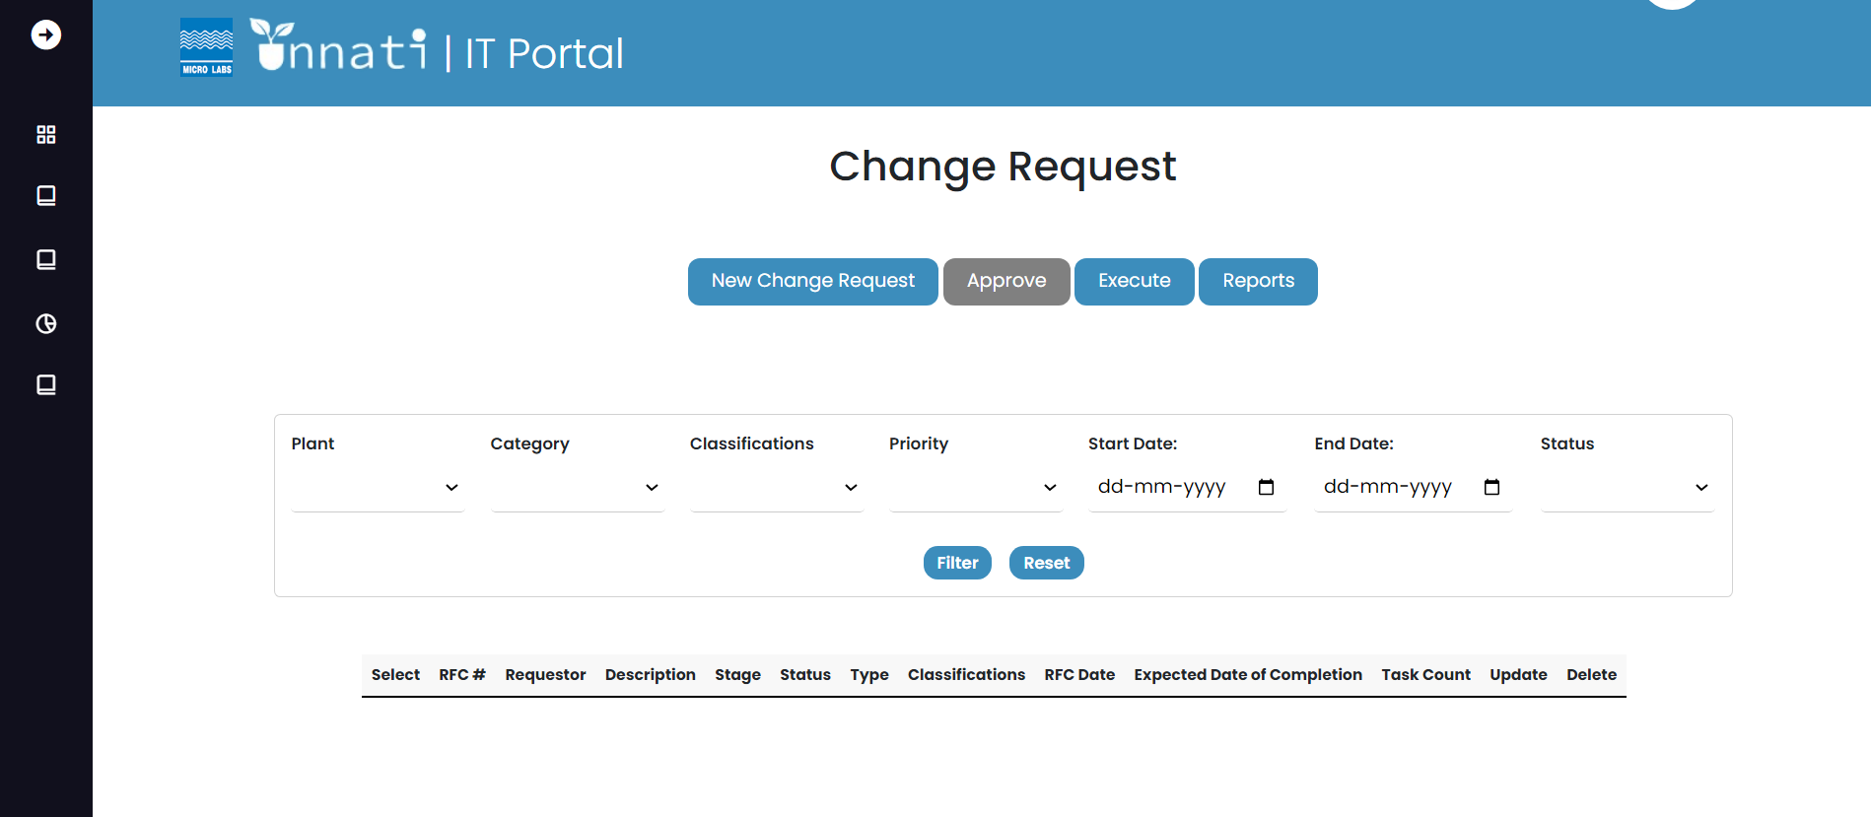

Approver:

As an approver you will be able to read the CR but you don’t have the access to update the CR, as approver you will be able to see only Approve button and Reports button.

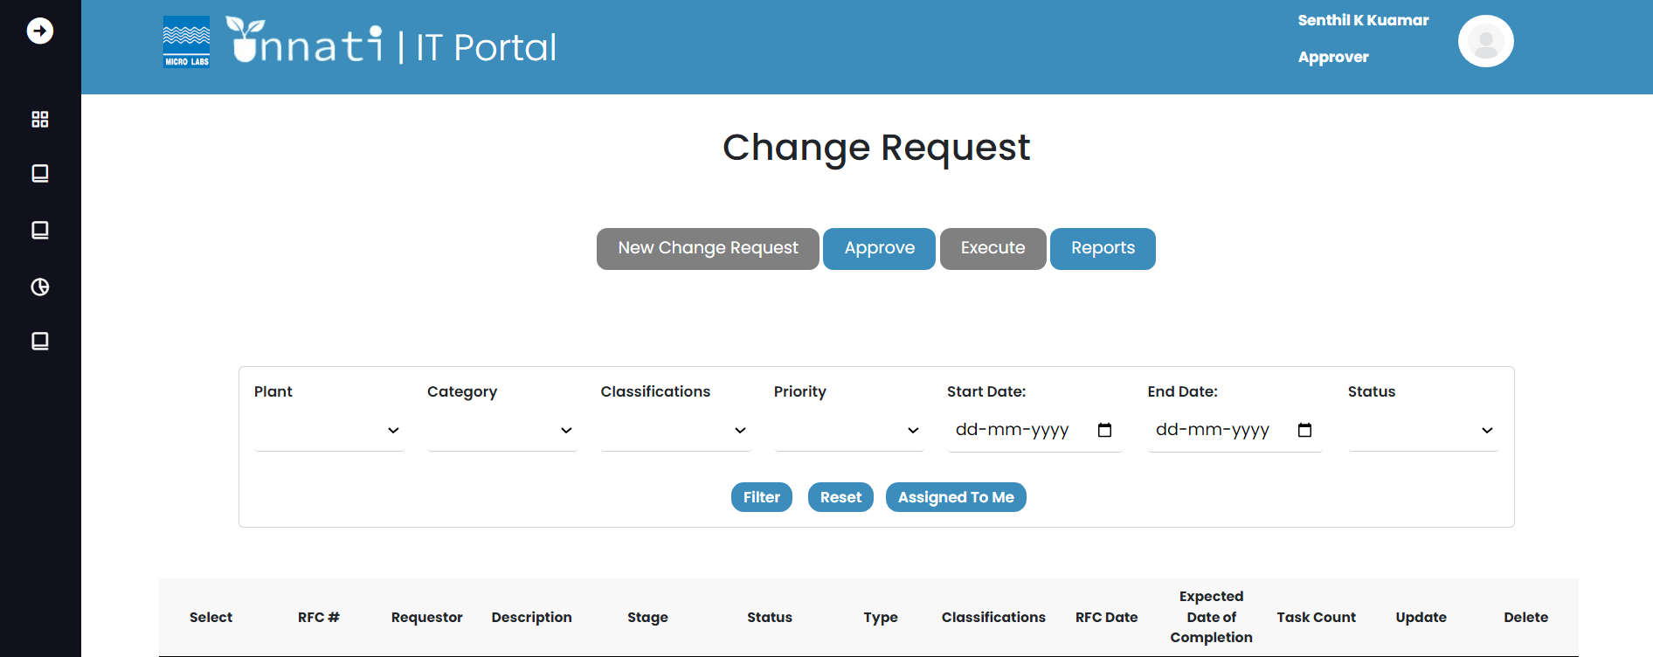

As you have logged in as approver you will be able to see the CR in in pending Approval and you will be able to see the particular CR assign to you based on the Classification and Category for particular User.

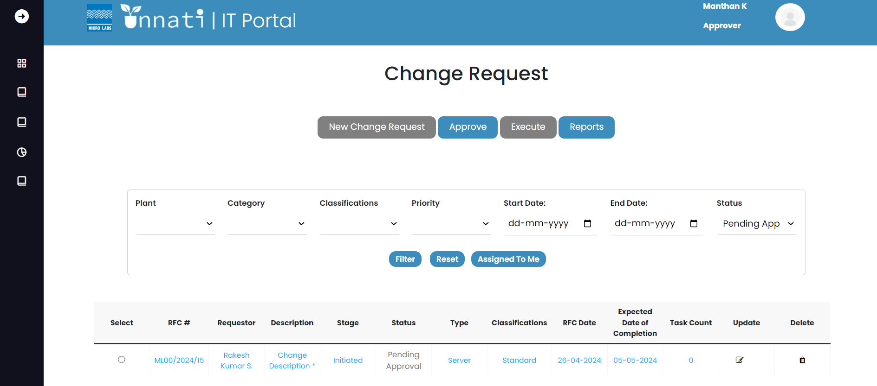

To approve the CR, select the particular CR by clicking on the radio button of the particular CR and click on the Approve button.

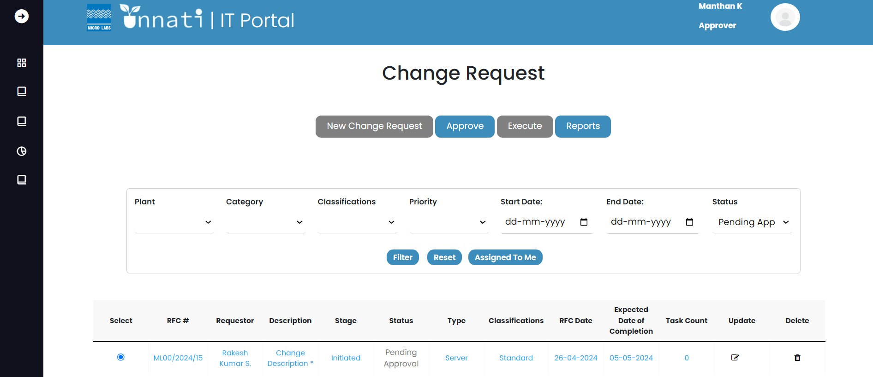

Once you oopen the cr you will be ab

Le to see the rfc no, cr created date and a status bar for a particular CR, and as the status is still not approved the status of particular CR will be highlited in orange colour which means the current status is not updated for the particular CR.

By clicking on the RFC button the user can read the CR details but not be able to modify it and the Blue button for approver which shows that you are in approver phase level 1 and you can read the history of the particular CR by clicking on History button. And it also give the name of the particular approver name.

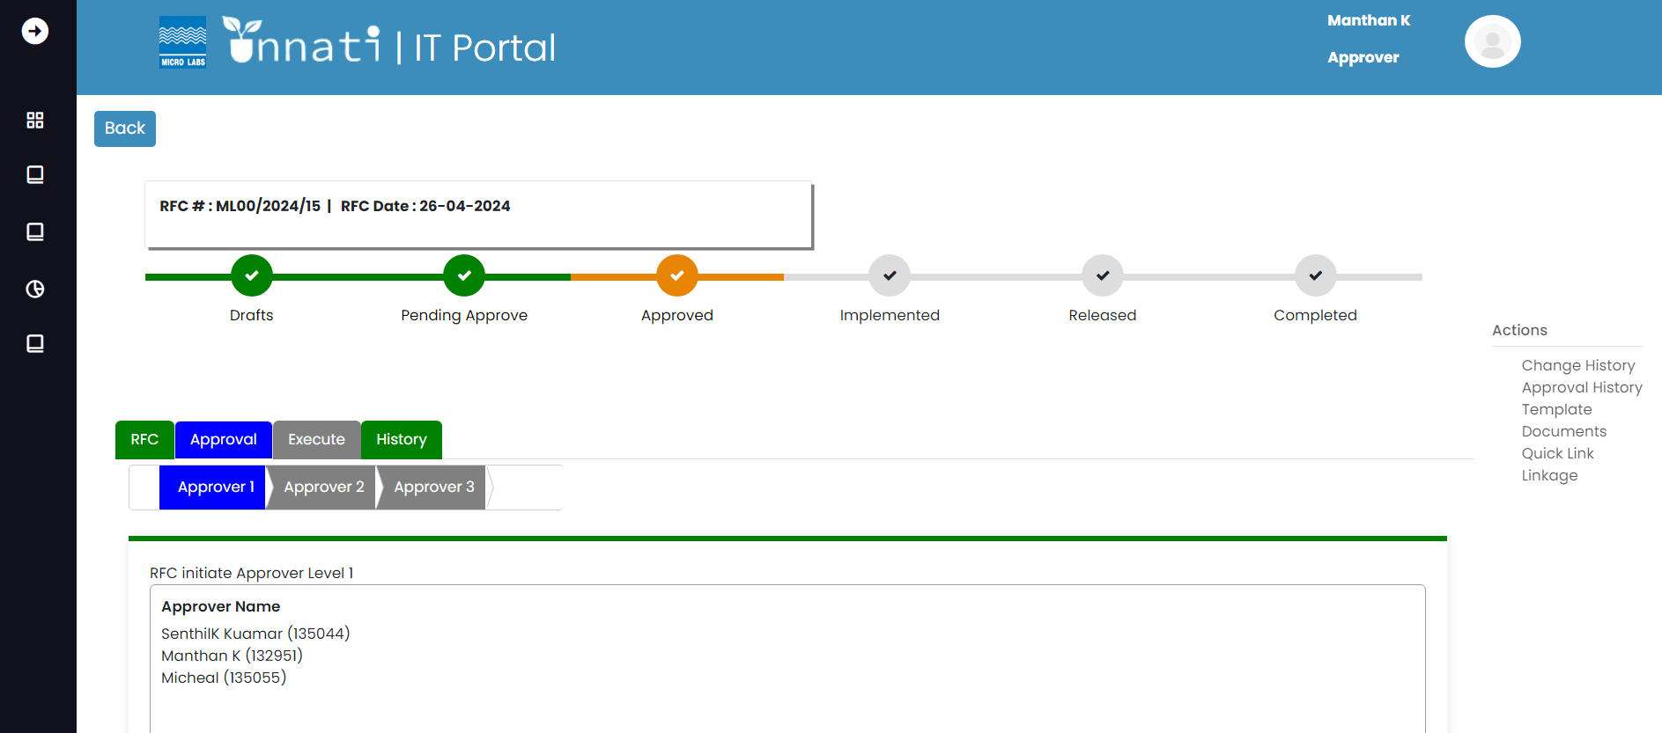

In this section the user can capture the remarks and can attach the documents in the attach document section and click on approve by doing this you are approving the level 1 and the user can reject the CR for any valid reason or can click on seek clarification for further clarification/ update.

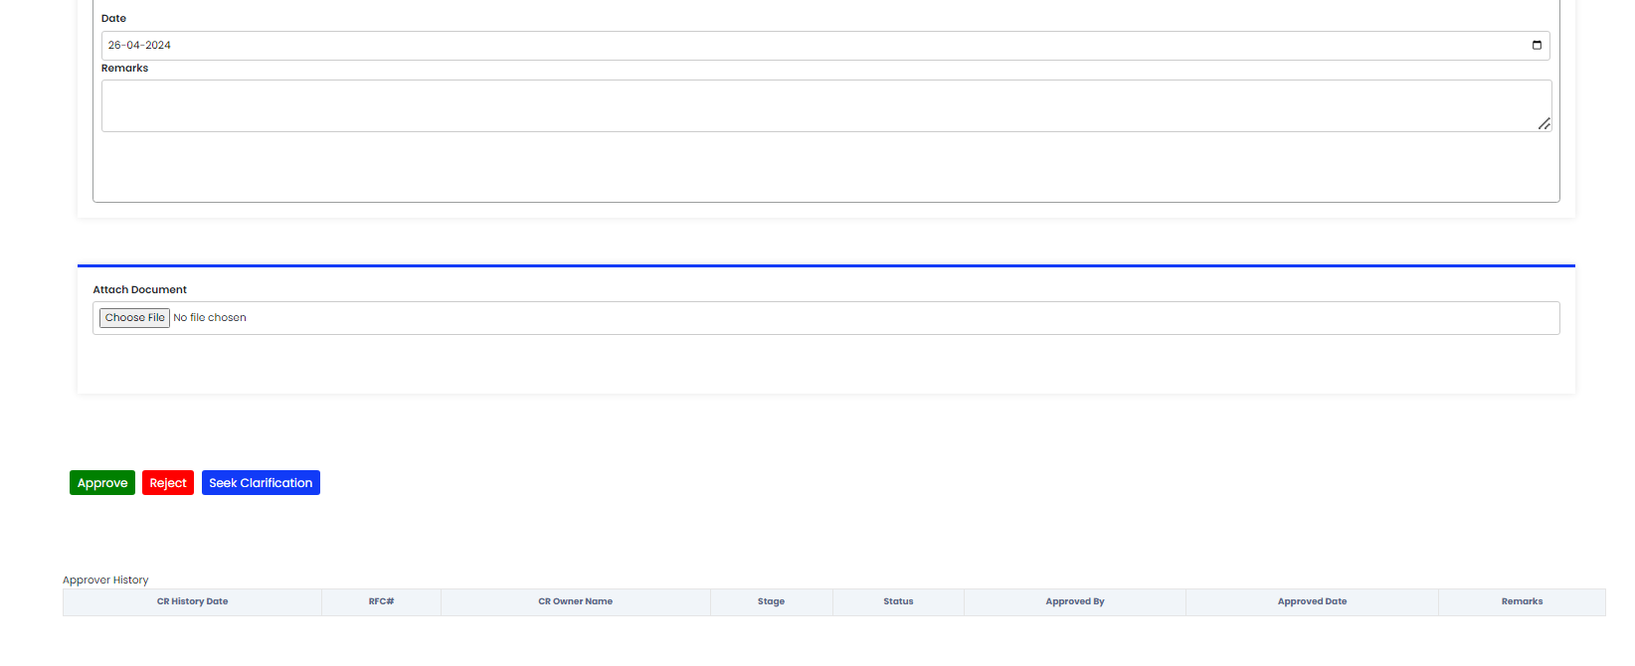

As you have approved the level1 the status got updated to approved level1.

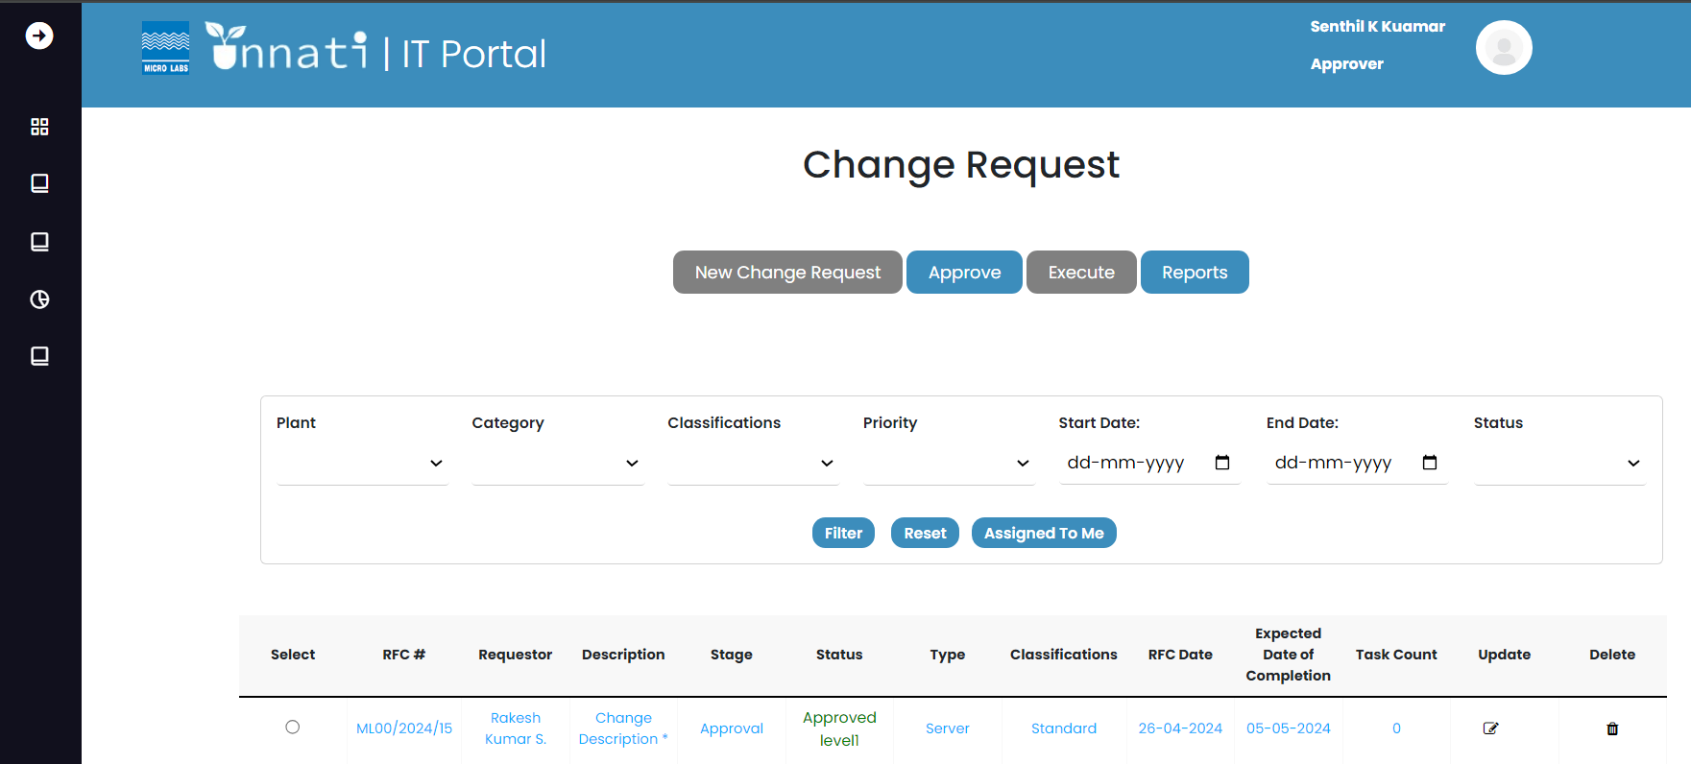

Now we are in the level2 phase you can see the approver level 1 color has changed from blue to Green, As you are the level 1 approver you will not be having the access to approve the level 2 and you will not be able to see the name of level1 approver and the following buttons- Approve, Reject and Seek clarification. So the following CR has to approve by level2 approvers.

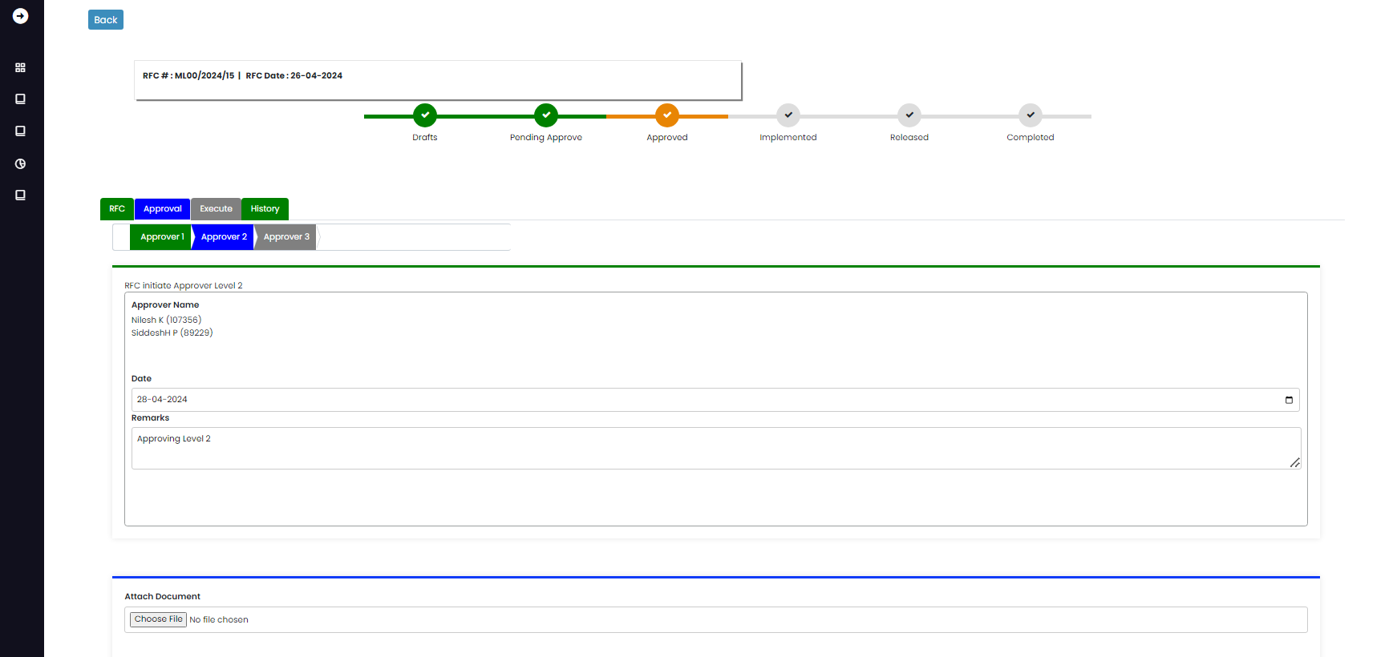

Level2 approver:

As a level2 approver you can see that that approver2 is blue in color now it means that you are in approval level2 phase.

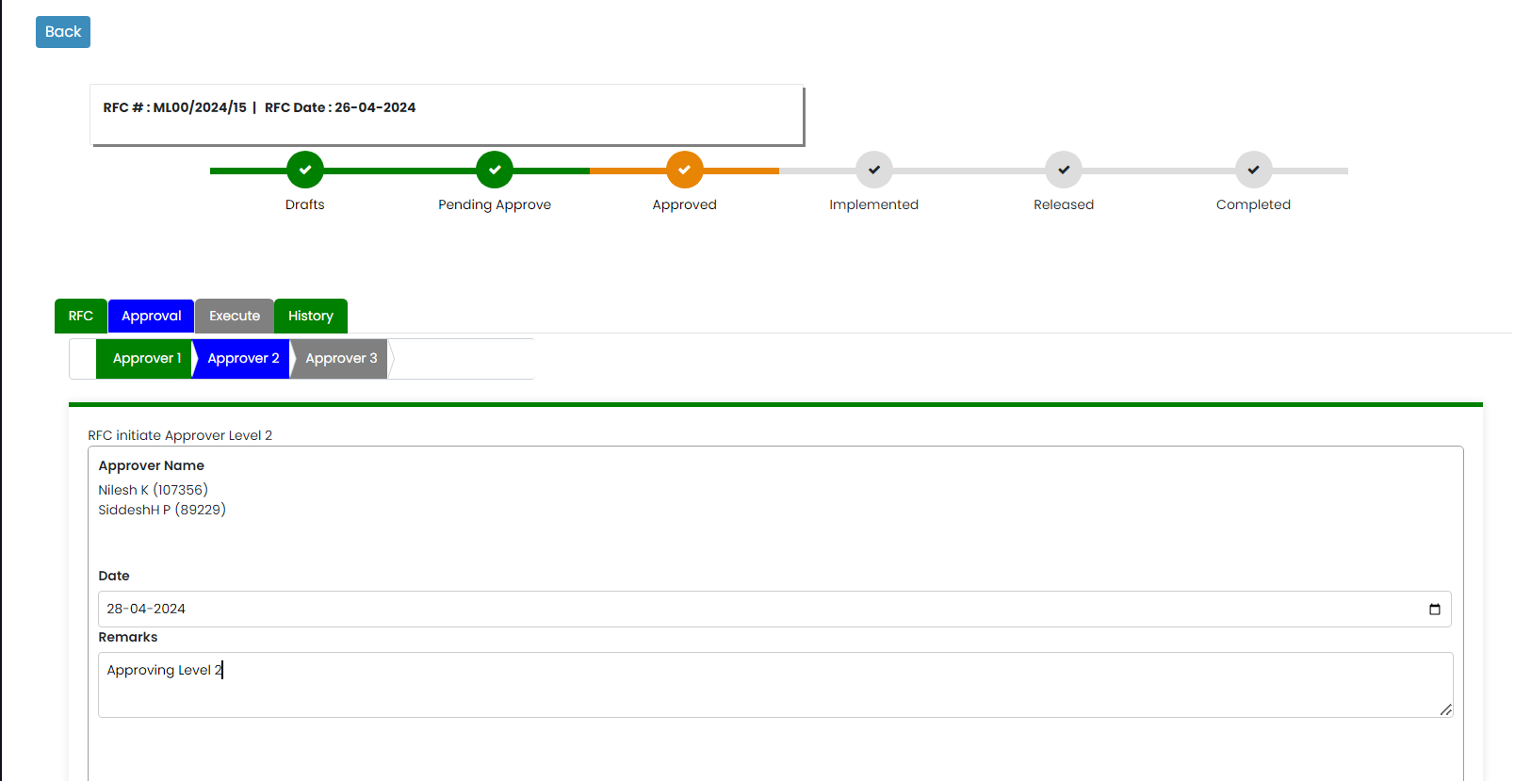

Here you can update your remarks and read the previous remarks in approval history in remarks section once you update remarks and clicks on approve the remarks got updated.

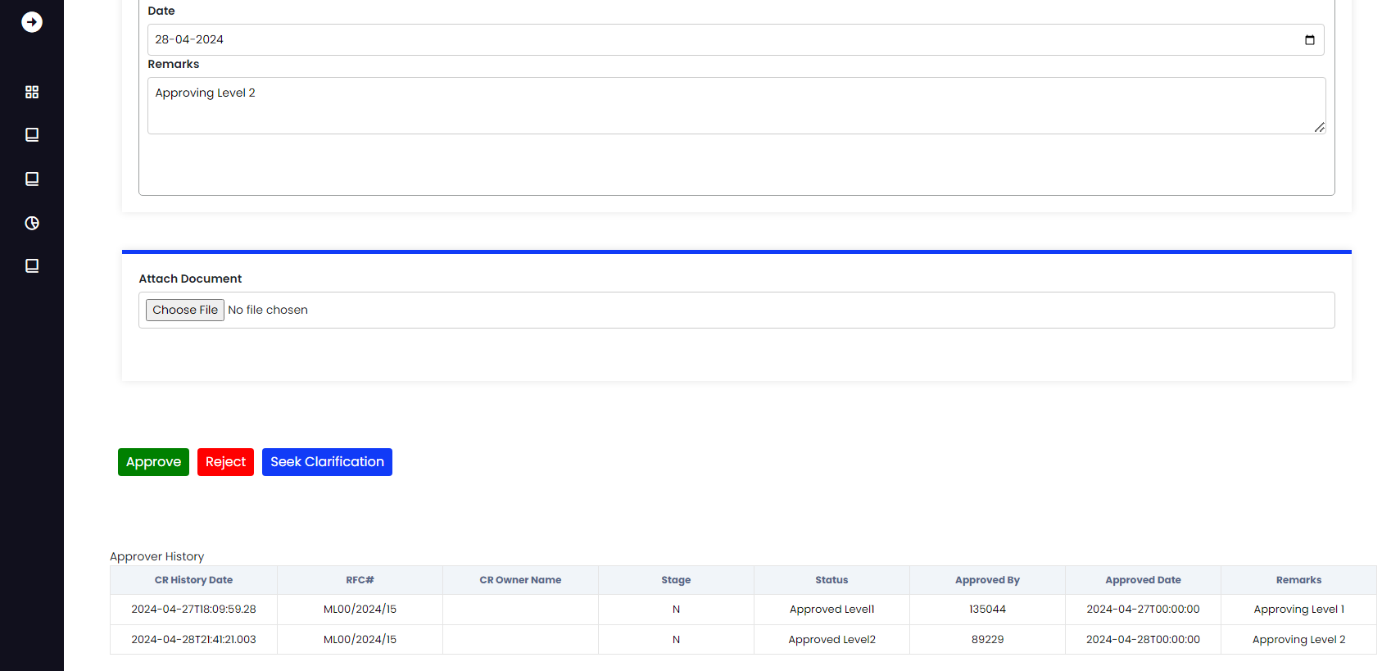

As the approval level 2 was approved the CR status got updated to Approved level2.

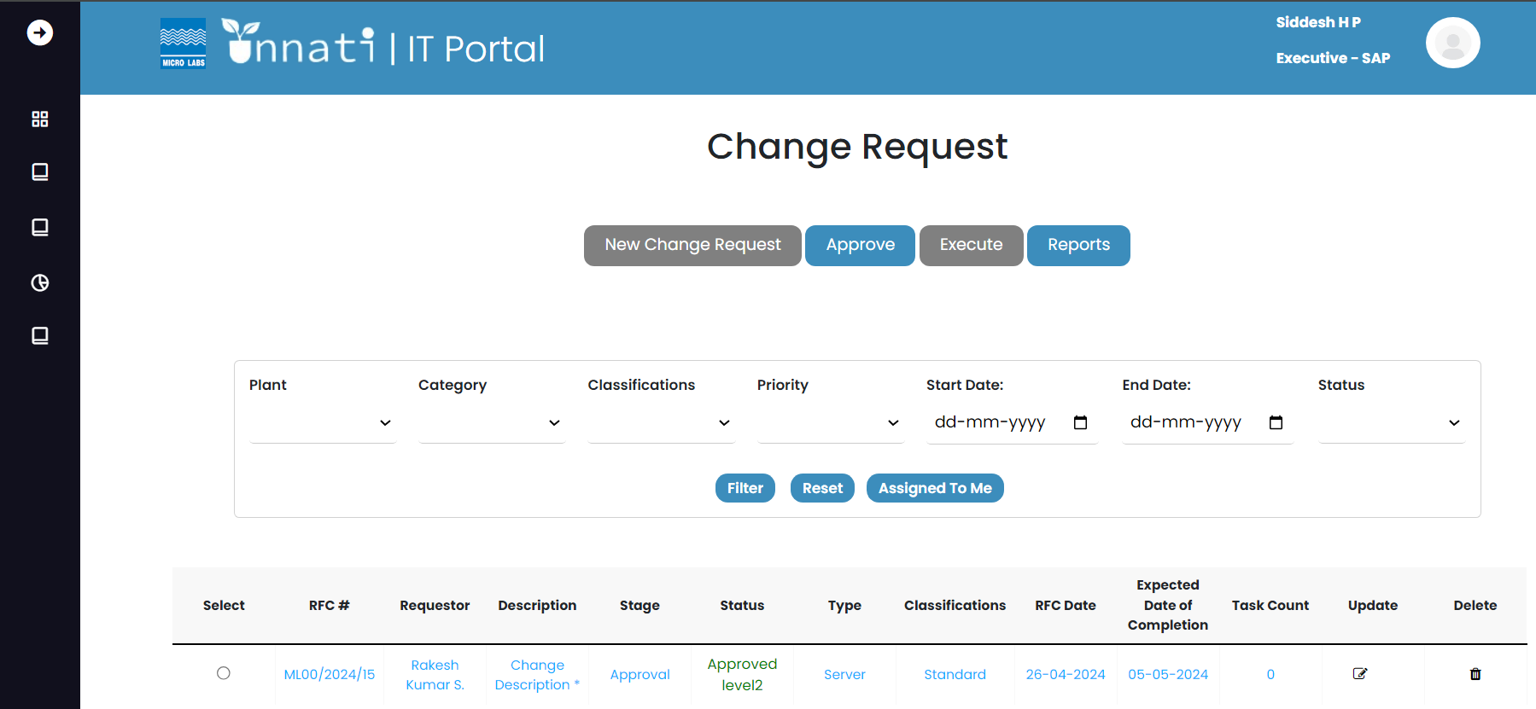

Here as we entered Approver level3 phase and you can see the approver level 1 and leve2 color has changed from blue to Green, as you are the level 2 approver you will not be having the access to approve the level 3 and you will not be able to see the name of level2 approver and the following buttons- Approve, Reject and Seek clarification. So the following CR has to approve by level3 approvers.

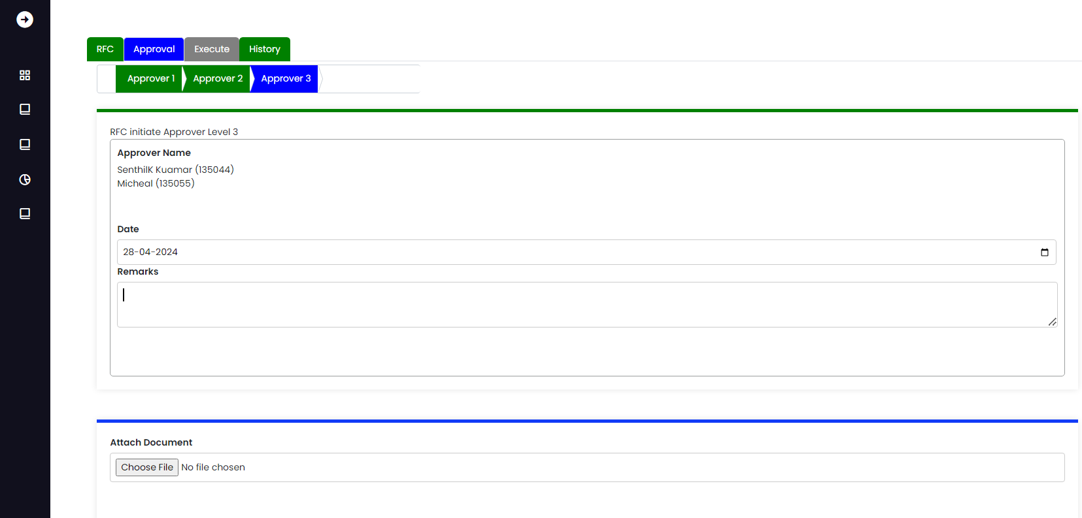

Level3 Approver:

As a level3 approver you can see that that approver1 and 2 is Green in color and approver3 is in blue color now it means that you are in approval level3 phase and you can see your name in the Approver list.

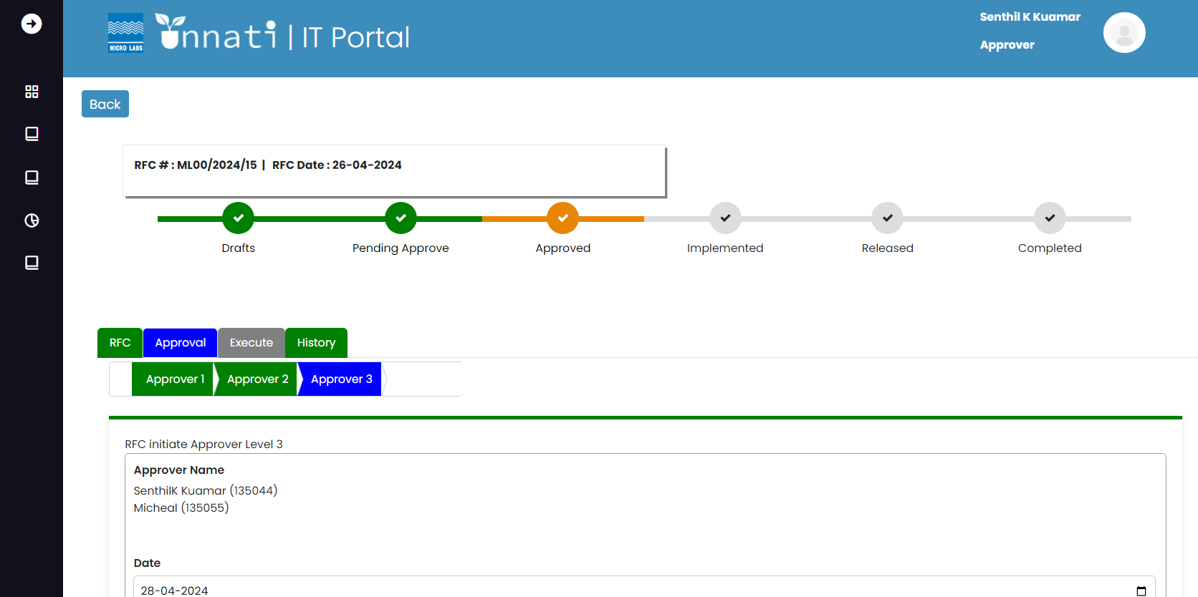

Once you update the remarks and click the approve button the remarks got updated and the status on the status bar changed to Approved and all approver levels turned green in color.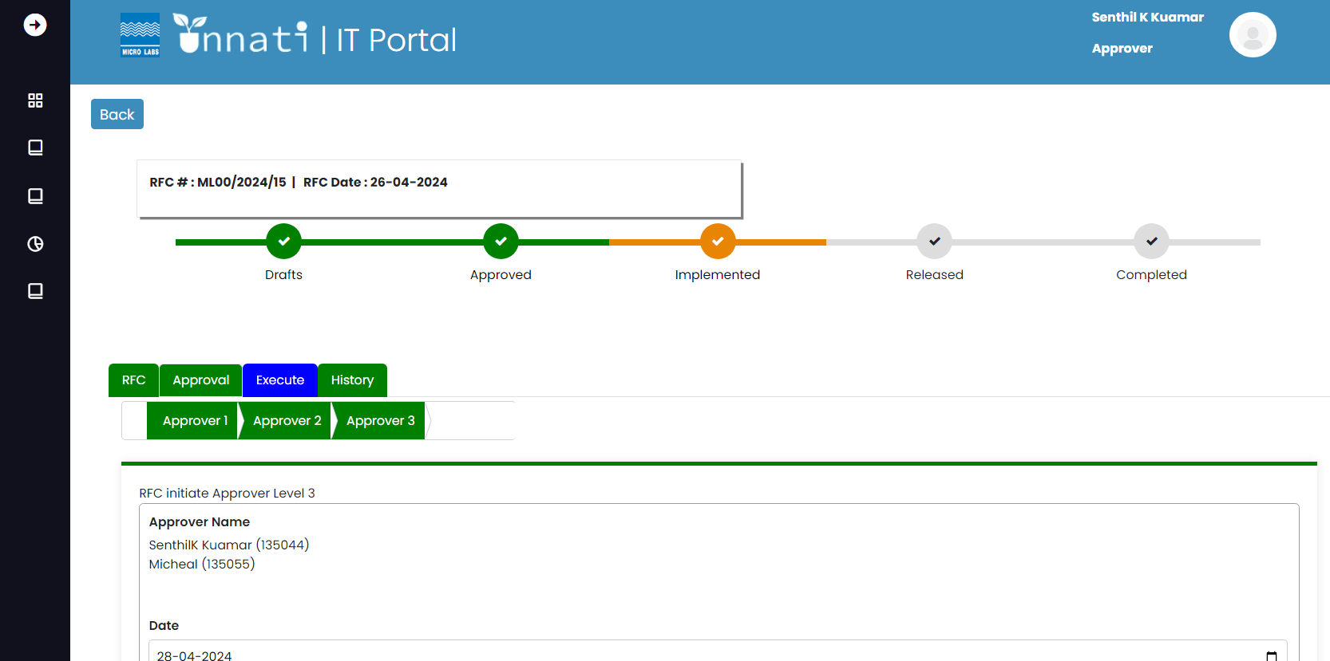

All the Approver levels details and remarks of all the approvers got updated in the Approver history table.

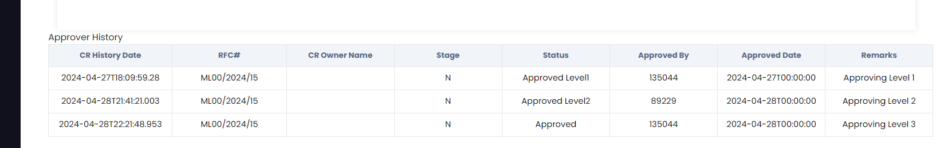

The Status of the CR got updated from approved level2 to Approved.

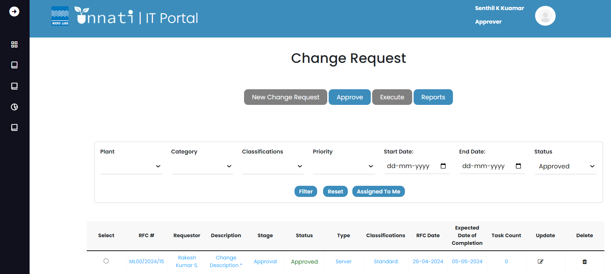

Execute-Implementation:

Change analyst/ Support Engineer is responsible for the Task created, as we are in implementation phase the status bar for implemented is in orange color, and all the approver labels are green in color and execute tab is blue in color it means that we are in the execution part of the CR, the system landscape depends based on the classification, category of the CR.

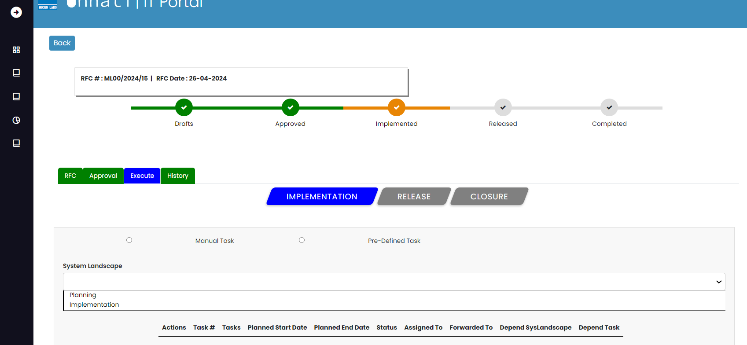

Task creation:

As we have planning and Implementation in the system landscape we will create a Task for planning. To create a task, select planning from the dropdown once planning is selected the add new task button appears in the left side of the bottom click on it.

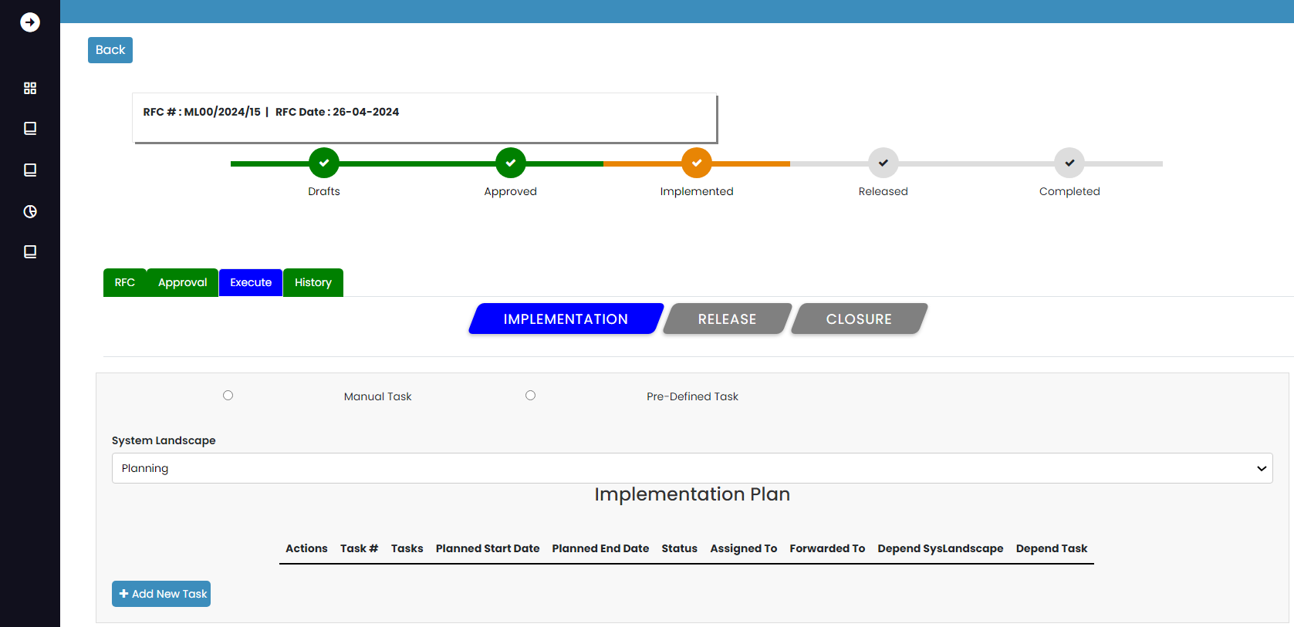

Once clicked on add new task button this is how the new task form looks like.

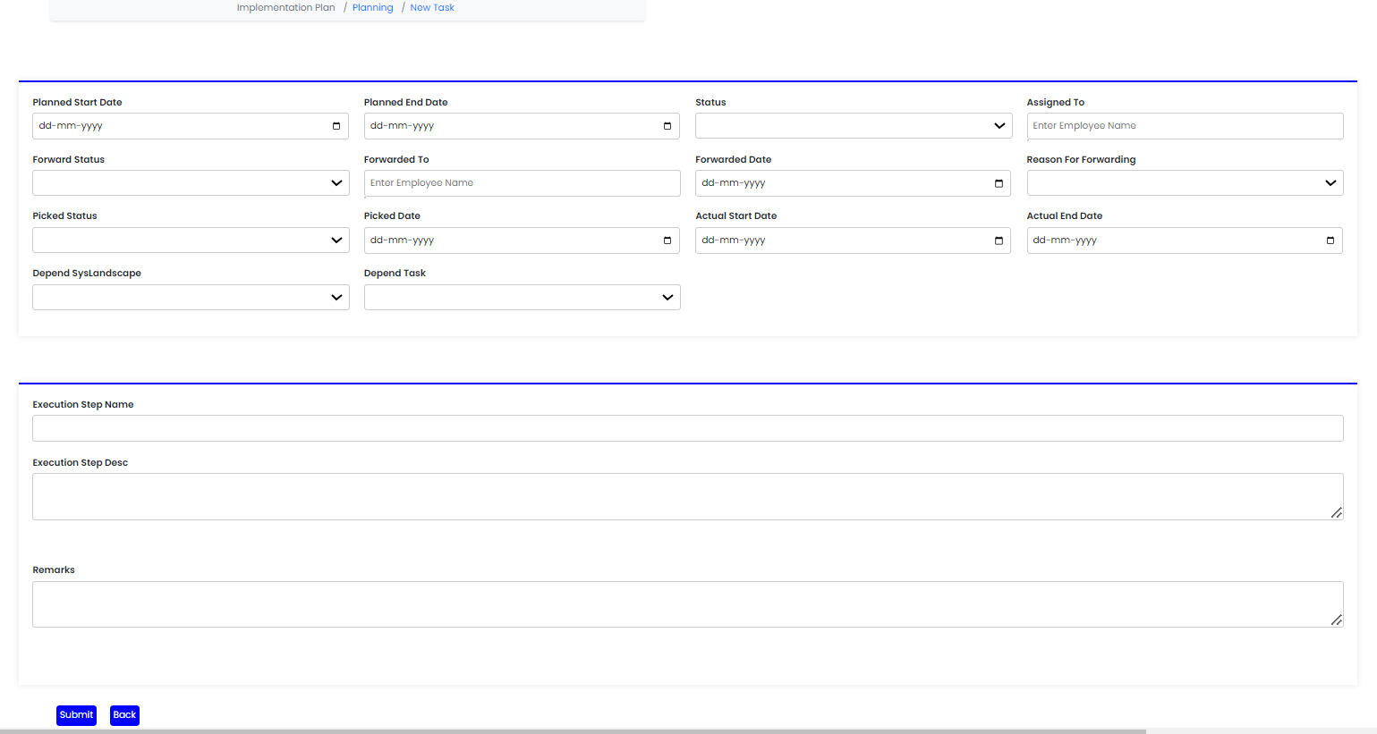

Enter all the required field of the form.

Note: as it is a first task it will be independent i.e. there will be no dependent task for this, once you enter the required data you can click on submit button.

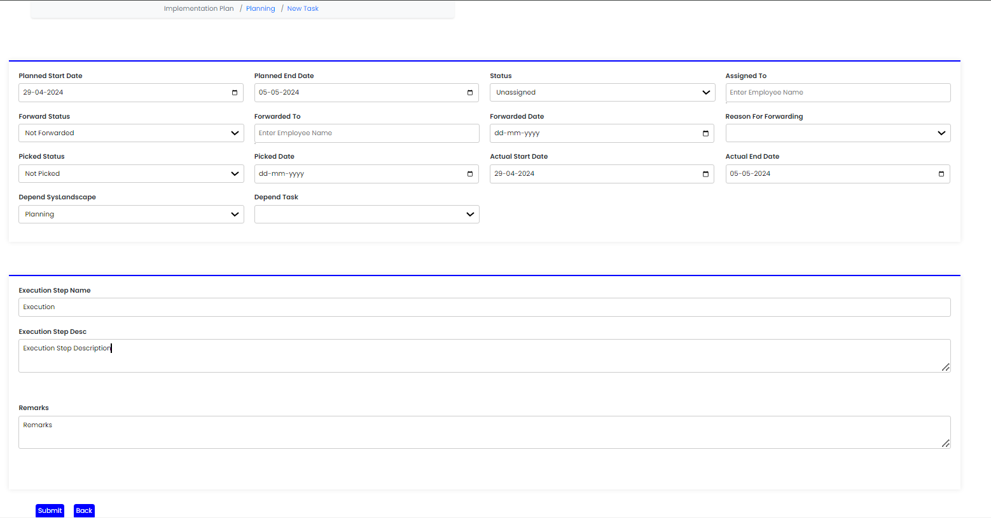

Once you submit it you will get a pop message saying added successfully.

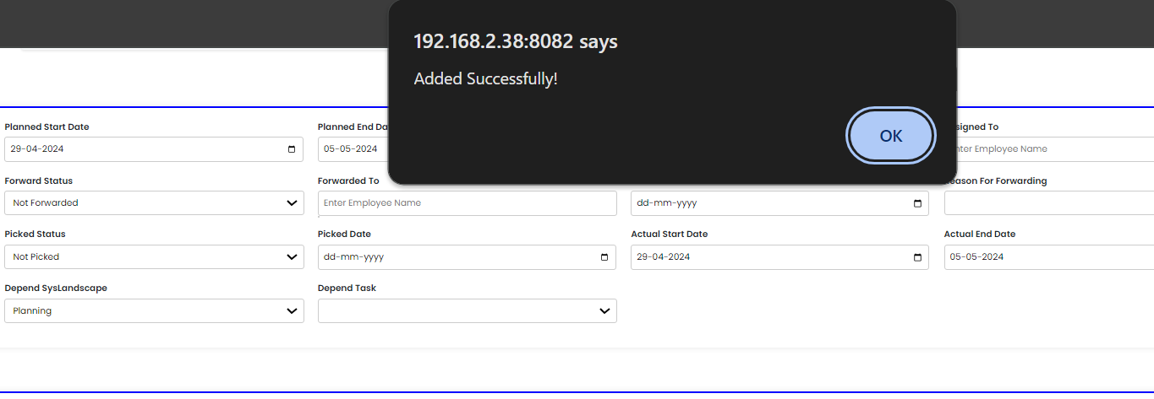

As the task got created this is how its look like. as we have created a 1 task it is visible in the table where it’s shows that task no, Task name, planned start date, end date status, assigned to, forwarded to Depend system landscape and depend task. We can add n number of task. 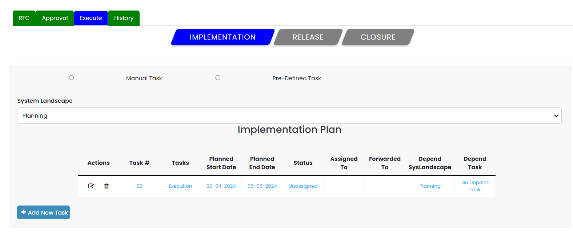

If want to add more task, click on add new task and can create a new as it will second task it will be dependent task.

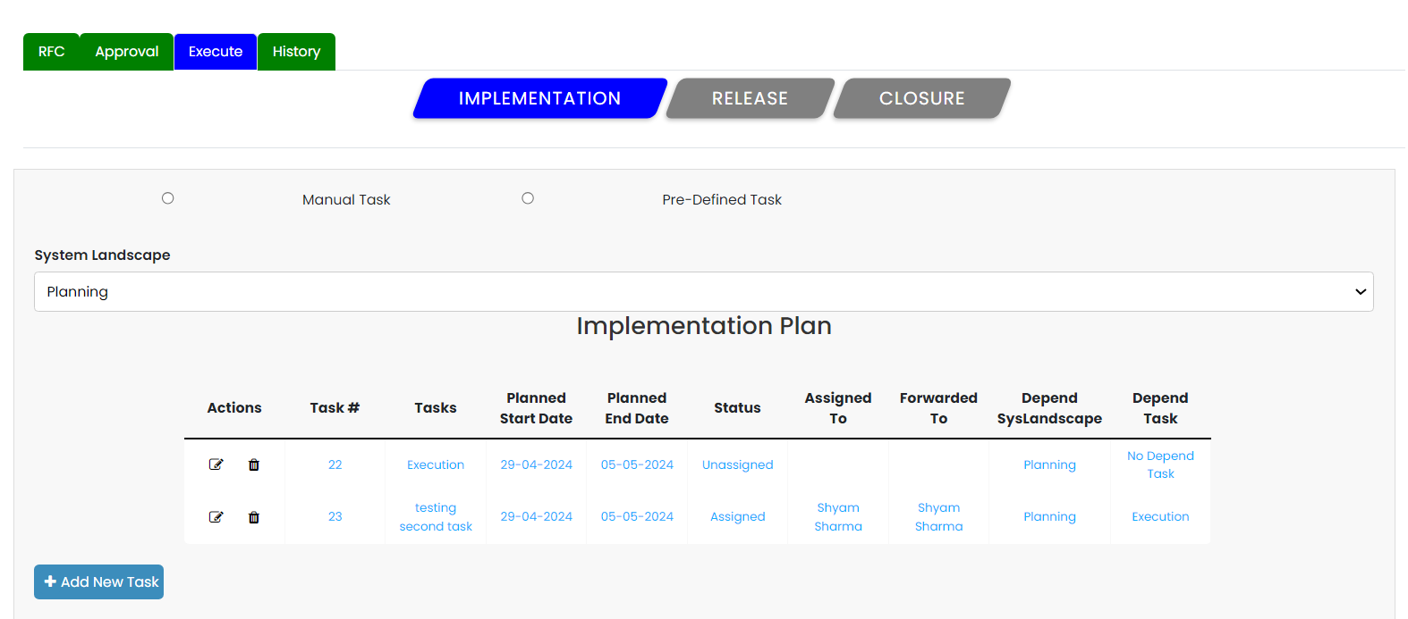

Will create a task for Implementation, to create a task, select Implementation from the dropdown once Implementation is selected then click on add new button.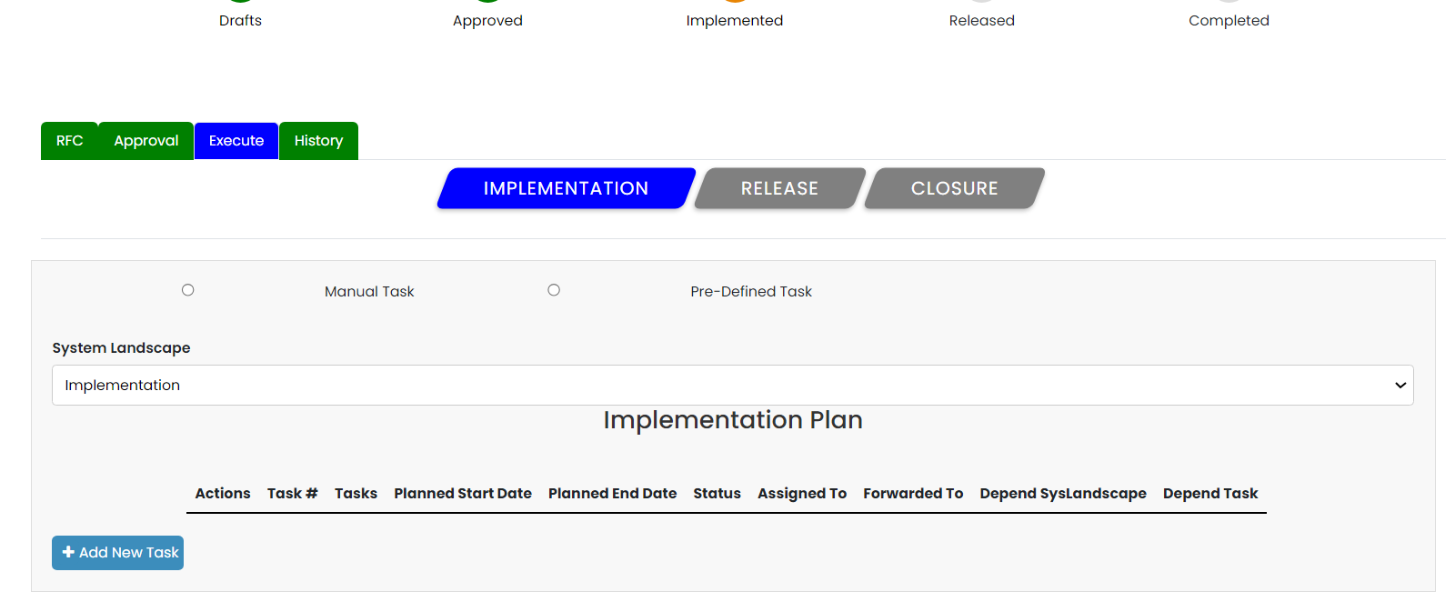

as we have created a 1 task for implementation it is visible in the table.

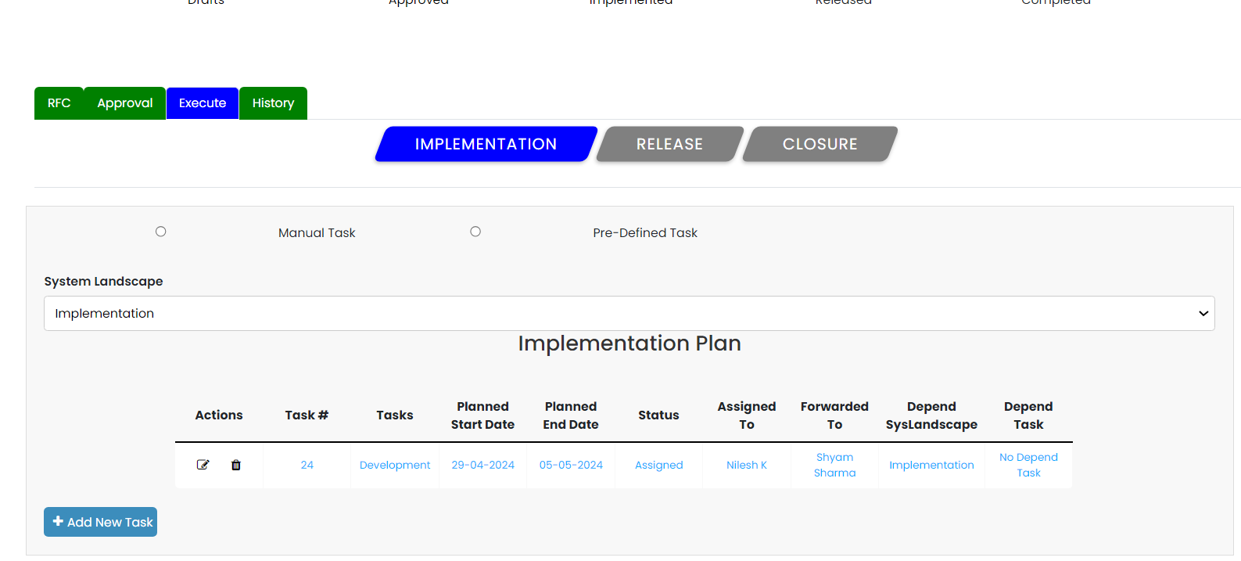

To enter the next step of execute that is release all the created task status has to be updated as completed, even if 1 task status is assigned, unassigned, on hold the submit for release button will not appear. To update the status of the task select the particular task from the lasndscape and click on update button and change the status to next level until it its completed. 

As there are total 3 task were created its displays the task count on the CR in home page, and the status for the same CR got updated as implement.

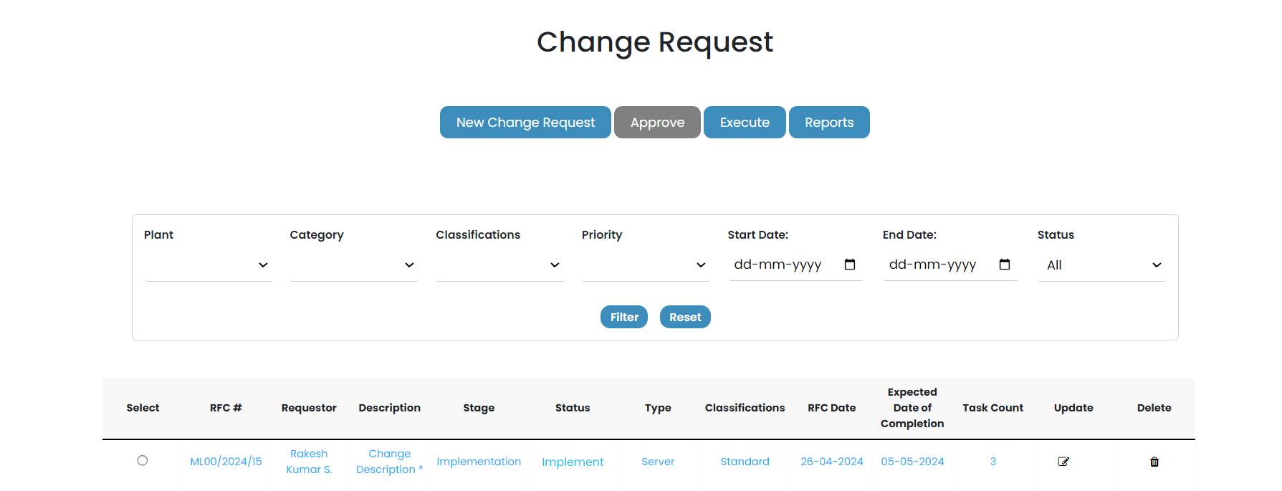

Once all the task status get updated as completed the submit for release button will appear.

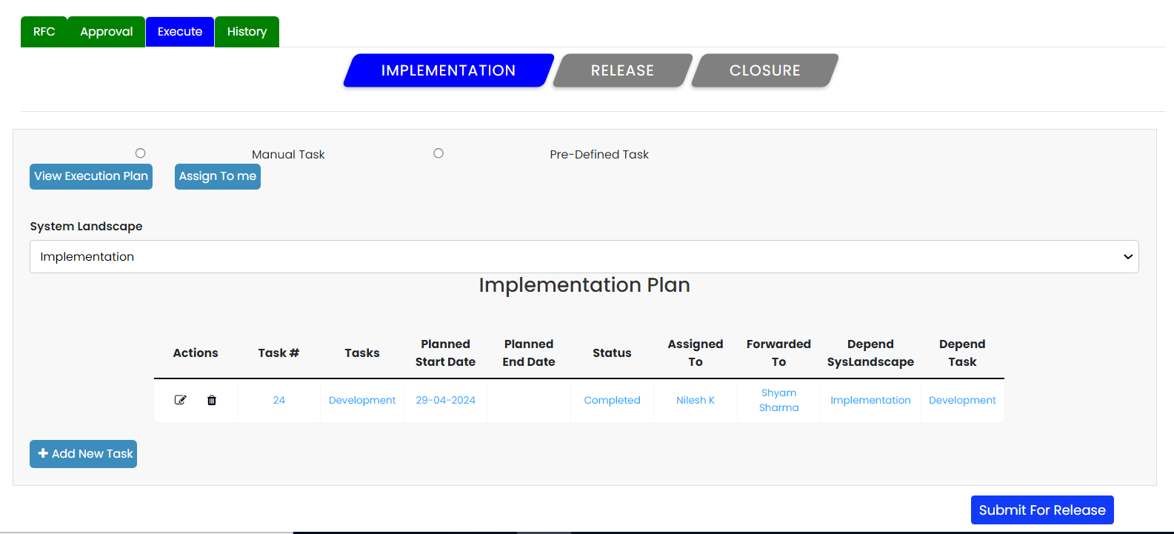

Once clicked on submit for release it will give you a message pop saying implemented successfully.

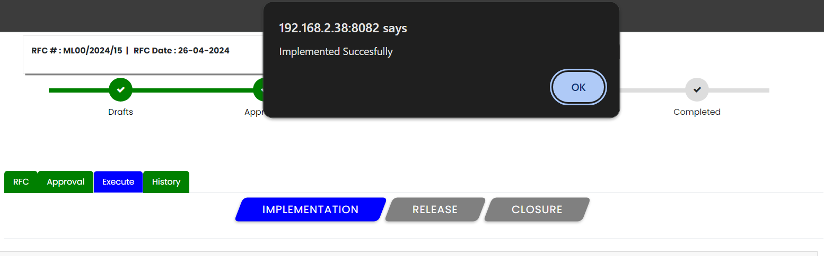

And the status will have updated as implemented.

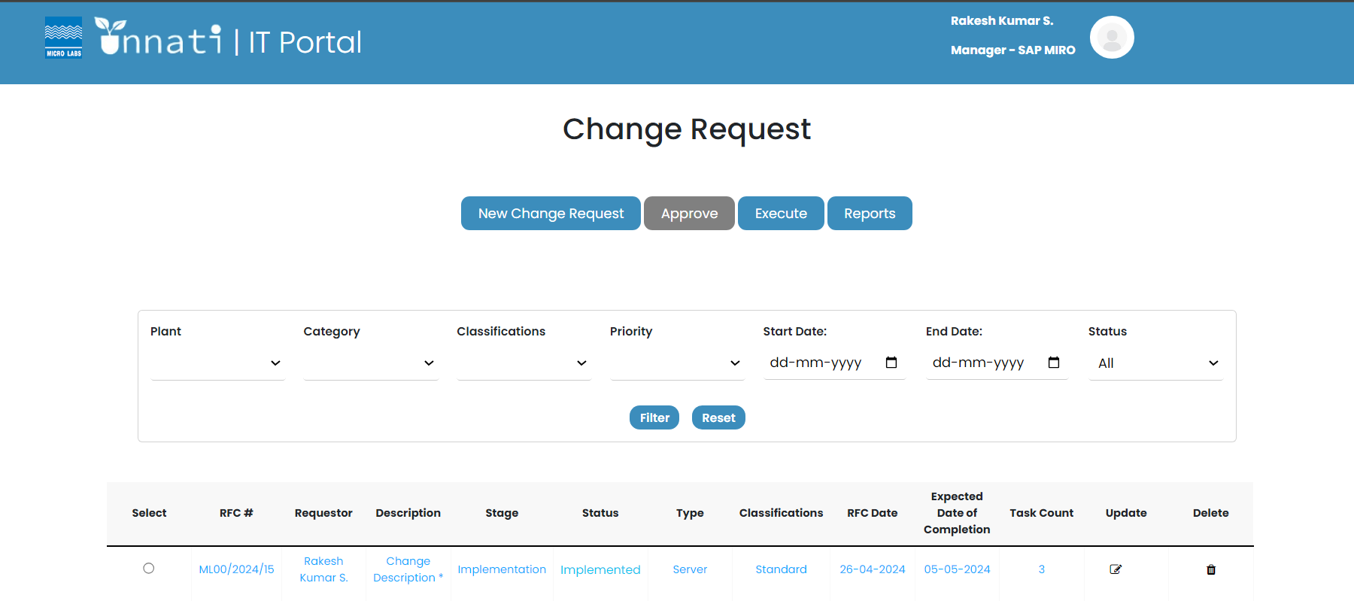

As the implementation is completed the status bar of the particular CR has updated as implemented and the implementation button color changed to green and released changed to blue.